THIRD TERM
Subject: MATHEMATICS Class: SS 1 DURATION ; 2Hrs

PART1: OBJECTIVES- 1HR
- Simplify 2 –log₂₅5 A. 1¹/₂ B. 2¹/₂ C. 5¹/₂ D. ½
- Find x if log₉x = 1.5 A. 72 B. 27 C. 36 D. 3.5
- The edge of a cube whose volume is equal to the volume of a cuboid of dimensions 63 cm × 56 cm × 21 cm is (A) 21 cm (B) 28 cm (C) 36 cm (D) 42 cm
- If radius of a sphere is doubled, then its volume will become how many times of the original volume? (A) 2 times (B) 3 times (C) 4 times (D) 8 times
- Volume of a cylinder of the same base radius and the same height as that of a cone is (A) the same as that of the cone (B) 2 times the volume of the cone (C) 3.1 times the volume of the cone (D) 3 times the volume of the cone.
Use the information below for questions 6 to 8:
A dice is thrown 14 times and the scores were: 1, 6, 6, 4, 3, 5, 5, 4, 4, 4, 5, 2, 1, 6.
- Find the range (A)4 (B)3 (C)5 (D)6
- Find the median score (A)4 (B)3 (C)5 (D)6
- Find the mode score. (A)4 (B)3 (C)5 (D)6
- Find the mode, median, and range of 50%, 55%, 60%, 70%, 65%.(A) 0.55 (B)0.6 (C)0.65 (D)0.70
Use the information below for questions 10 to 12:
Given that U ={all positive integers from 1 – 10}, A ={all odd numbers 10}, B ={all even numbers < 10} and C ={all prime numbers }
- Find n (A B) ^{I}. (A) 10 (B) 1 (C) 0 (D) .
- Find (AC) ^{I} B. (A) {3 – 8} (B) {3, 5, 7} (C) {1, 2, 3, 8, 9} (D) {2, 5, 7, 6, 10}.
- Find n (A^{I} B^{I} C^{I}). (A) 2 (B) 0 (C) 1 (D) {0}.
- Evaluate x . (A) 20 (B) 5 (C) 1/20 (D) -20.
- Simplify; (216)^{-2/3} x (0.16)^{-3/2.} (A) 2/125 (B) 125/288 (C) 4/225 (D) -2/225.
- Simplify; 2^{n-1} x 4^{2n+1} 8^{3n} where n = 1. (A) 1/8 (B) 1/16 (C) -8 (D) 16.
- Which of the following is the solution to the equation; 2x² + 3x - 5? (A) 5 and -2 (B) -2 and -5 (C) 2 and 5 (D) -5 and 2.
- Simplify 8^{2/3} x 4^{-1/2} 16^{3/4}. (A) 1/16 (B) 1/24 (C) 16 (D) 8.
- Given that 2^{x} = 0.125, find the value of x. (A) -2 (B) 8 (C) 14 (D) -3
- Simplify Log_{1.5} 2.25 = 2. (A) 1 (B) -1 (C) 2 (D) -3.
- Simplify 8^{2/3} x 4^{-1/2} 16^{3/4}. (A) 1/16 (B) 1/24 (C) 16 (D) 8.
- Given that 2^{x} = 0.125, find the value of x. (A) -2 (B) 8 (C) 14 (D) -3.
- The curved surface area of a cylinder, 5cm high, is 110cm². Find the radius of its base.( take =) (A) 2.6cm (B) 3.5cm (C) 3.6cm (D) 7cm
- The volume of a pyramid with height 5cm is 90cm³. If its base is a rectangle with dimensions xcm by 6cm, find the value of x. A. 3 B. 5 C. 6 D. 8
- Make “s” the subject of the relation: p = s +
(A) s = (B) s = 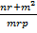 (C) s = (D) s =
- Factorise: (2x + 3y)² – (x – 4y)²
(A)(3x – y)(x + 7y) (B) (3x + y)(2x - 7y) (C) (3x + y)(x - 7y) (D) (3x – y)(2x + 7y)

P Q R
48⁰

S T U V

60⁰
W X Y
In the diagram, PR//SV//WY, TX//QY, <PQT = 48⁰ and <TXW = 60⁰. Find <TQU
(A) 120⁰ (B) 108⁰ (C) 72⁰ (D) 60⁰
- The ratio of the exterior angle to the interior angle of a regular polygon is 1:11. How many sides have the polygon? A. 30 B. 24 C. 18 D. 12
- Halima is n years old. Her brother’s age is 5 years more than half of her age. How old is her brother? A. + B. - 5 C. D. + 5
- An object is 6m away from the base of a mast. If the angle of depression of the object from the top of the mast is 50⁰, find, correct to 2 decimal places, the height of the mast. A. 8.60m B. 7.83m C. 7.51m D. 7.15m
- The coefficient of a² in the expression 3a² – 2a + 25 A. 25 B. -2 C. 2 D. 3
- Find the sum of 1001_{two} and 111101_{two} A. 100001_{two} B. 100011_{two} C. 100110_{two} D. 1000110_{two}
- How many vertices have a cuboid? A. 4 B. 6 C. 8 D. 12

- Given that log_{x} 64 = 3, evaluate x log₂ 8 (A) 6 (B) 9 (C) 12 (D) 24
- If 2^{n} = y, find 2^{(2 + n/3)} (A) 4y^{1/3} (B) 4y⁻³ (C) 2y^{1/3} (D) 2y⁻³
- If m = 4, r = 16 and n = 9, evaluate ^{m}/_{n} – 1⁷/₉ + ^{n}/_{r} (A) 1⁵/₁₆ (B) 1¹/₁₆ (C) ⁵/₁₆ (D) -³⁷/₄₈

p

m n
From the diagram, which of the following is true? (A) m + n + p = 180⁰ (B) m + n = 180⁰ (C) m = p + n (D) n +p= m +180
- In the diagram below, is a chord of a circle KMN centre O and radius 10cm. if <MON = 140⁰, find, correct to the nearest cm, the length of the chord MN. A. 19cm B. 18cm C. 17cm D. 12cm
K

O
140⁰
M N
- If 23_{x} + 101_{x} = 130_{x}, find the value of x. A. 7 B. 6 C. 5 D. 4
- Simplify: ( - ) x 1. A. B. D.1
- A motorcycle is paid for in twelve equal installments. Each payment is 5,500. How much does the motorcycle cost? A.66,000 B.15,000 C.32,000 D.60,000
- Solve 1 + 2m > 3m + 5 A. m > 4 B. m > -4 C. m < 4 D. m < -4
- Express - as a single fraction A. B. C. D.
- Express 526000 in standard form: A. 5.26 x 10⁴ B. 5.26 x 10⁻⁴ C. 5.26 x 10³ D. 5.26 x 10⁵
- If 5 people can do a piece of work in 6 days, how many days should 10 people take to do it? (Assume that the rate of work is the same) A. 4 B. 5 C. 7 D. 3
- 0.5046 correct to 3 decimal places A. 0.5050 B. 0.504 C. 0.50 D. 0.505
- The square root of 12 is A. 1 B. 3 C. 3 D. 6 E. 6
Use the figure below for questions 45-47
Below is a chart of favourite colours of selected people.
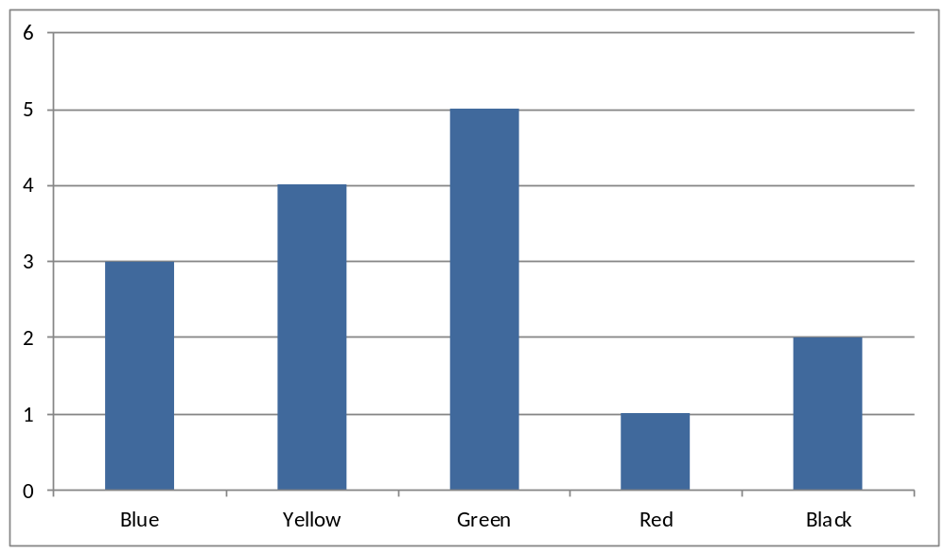

- Which is the most popular colour? A. blue B. yellow C. green D. red
- Which is the least popular colour? A. blue B. yellow C. green D. red
- How many people were asked to name their favourite colours? A. 5 B. 10 C. 12 D. 15
- T

cm

W cm X 1cm U
In the diagram, TX is perpendicular to UW,/UX/ 1cm and /TX/ = /WX/ = cm. find <UTW A. 135⁰ B. 105⁰ C. 75⁰ D. 60⁰

